**Computer Networks**

The interconnection of computing devices and they will communicate with each other to exchange information.

Sliding Window:-

Sliding Window Protocol is a fundamental method used in **data link layer** and **transport layer** to ensure **efficient, reliable, and ordered delivery** of packets/frames. There are **three main types** of sliding window protocols:

**✅ 1. Stop-and-Wait**

* **Concept**: Sender sends **one frame**, waits for **ACK**, then sends the next.
* **Window Size**: 1
* **Efficiency**: Low — sender is idle while waiting.
* **Use Case**: Very simple systems, low-latency links.

**Characteristics:**

* No pipelining.
* Easy to implement.
* Suitable for low-speed or highly reliable links.

**✅ 2. Go-Back-N**

* **Concept**: Sender can send **multiple frames (N)** without waiting for ACKs. But if a frame is lost or corrupted, it **goes back and resends all frames from that one onward**.
* **Window Size**: N (where N > 1)
* **Efficiency**: Better than Stop-and-Wait but can be wasteful on error.

**Characteristics:**

* Sender maintains a window of N frames.
* Receiver only accepts frames **in order**.
* **No buffering at receiver** — discards out-of-order frames.

**✅ 3. Selective Repeat**

* **Concept**: Like Go-Back-N, but more efficient. Sender resends **only the specific frame(s)** that were lost or corrupted.
* **Window Size**: N
* **Efficiency**: High — minimizes retransmission.

**Characteristics:**

* Both sender and receiver maintain windows.
* **Receiver accepts out-of-order frames** and buffers them.
* **Complex implementation** compared to the other two.

**🔁 Summary Table:**

| **Protocol** | **Window Size** | **Retransmission Strategy** | **Receiver Buffers?** | **Efficiency** |
| --- | --- | --- | --- | --- |
| Stop-and-Wait ARQ | 1 | Whole frame | No | Low |
| Go-Back-N ARQ | N | From error frame onwards | No | Moderate |
| Selective Repeat ARQ | N | Only errored/lost frames | Yes | High (Best) |

Piggybacking:-

In piggybacking technique, Both transmitter technique will exchange the data, once data transfer is successful, the transmitter and the receiver will receive the ACKs.

ACK are of two types:

* 1. Positive:- Indicates successfully received data
  2. Negative:- Indicates some issue or loss of data

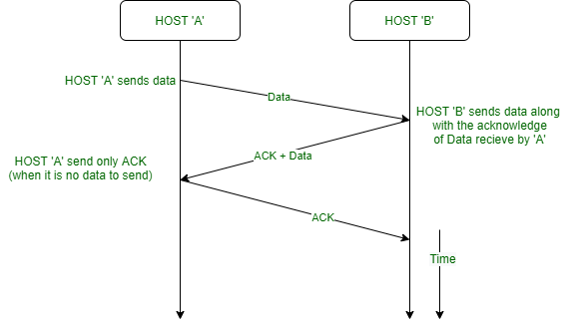

The data sent from transmitter is not same as the data sent by the receiver.

ALOHA:-

ALOHA is divided into 2 types:-

* 1. Pure Aloha
  2. Slotted Aloha

Multiple users will transfer the data without checking the channel availability, So there is a chance of data collision. It can be overcome with the help of CSMA (Carrier Sense Multiple Access)

In CSMA, Before sending the data we are checking the availability of the channel and if the channel is available then only we will transfer the data. If the channel is not available, then data transmission will not happen.

In Slotted Aloha, the entire time is divided into different time slots. The data transimissions happen at the beginning of each time slot.

**ALOHA** is a simple communication protocol developed for **wireless networks** to allow multiple devices to share the same communication channel.

**🌺 What is ALOHA?**

ALOHA is a **random access protocol** used for **medium access control** in computer networks. It was originally developed at the **University of Hawaii** in the 1970s to support wireless communication between the Hawaiian islands.

It allows multiple devices (stations) to **send data over a shared channel** without centralized coordination — but with a mechanism to **handle collisions**.

**🧠 Two Types of ALOHA:**

**✅ 1. Pure ALOHA**

* **Working**:
  + A station **sends data whenever it has data to send**.
  + It waits for an **ACK** (acknowledgment).
  + If no ACK is received within a time window, the station **assumes collision** and retransmits after a **random backoff time**.
* **Time is continuous**, meaning collisions can happen **at any moment**.
* **Vulnerable Time**: 2 × frame transmission time (T)

**✅ 2. Slotted ALOHA**

* **Improvement over Pure ALOHA**:
  + Time is **divided into slots**, and a station can only send **at the beginning of a time slot**.
  + Reduces chance of collisions since transmissions are synchronized.
* **Vulnerable Time**: 1 × frame time (T)

**📊 Comparison:**

| **Feature** | **Pure ALOHA** | **Slotted ALOHA** |
| --- | --- | --- |
| Time | Continuous | Discrete (slotted) |
| Vulnerable Period | 2T | 1T |
| Max Efficiency | ~18.4% | ~36.8% |
| Complexity | Simpler | Requires synchronization |

**💡 Real-World Use:**

* Basis for early wireless networks
* Inspiration for **CSMA (Carrier Sense Multiple Access)**, used in Ethernet and Wi-Fi
* Used in **satellite communication**

ISO OSI Layers:-

The **ISO OSI (Open Systems Interconnection)** model is a **conceptual framework** that standardizes the functions of a communication system into **seven layers**. It helps different networks and systems communicate with each other in a structured way.

**🧱 7 Layers of the OSI Model (Bottom to Top):**

| **Layer** | **Name** | **Function Summary** |
| --- | --- | --- |
| 7 | **Application** | User interface, network services (e.g., HTTP) |
| 6 | **Presentation** | Data format translation, encryption, compression |
| 5 | **Session** | Session control and synchronization |
| 4 | **Transport** | Reliable delivery, error recovery (TCP/UDP) |
| 3 | **Network** | Routing, logical addressing (IP) |
| 2 | **Data Link** | MAC addressing, frame transmission, error check |
| 1 | **Physical** | Bits over media: cables, signals, voltages |

**🔍 Layer-by-Layer Breakdown:**

**1. Physical Layer**

* **Deals with**: Raw bit transmission (0s and 1s)
* **Examples**: Cables, switches, fiber optics, voltages
* **Protocols**: None (just hardware-level)

**2. Data Link Layer**

* **Deals with**: Frames, MAC addresses, error detection
* **Functions**: Error checking (CRC), flow control, media access
* **Examples**: Ethernet, Wi-Fi (IEEE 802.11), PPP
* **Devices**: Switches

**3. Network Layer**

* **Deals with**: Packets and routing
* **Functions**: Logical addressing (IP), path determination
* **Examples**: IP, ICMP, IPsec
* **Devices**: Routers

**4. Transport Layer**

* **Deals with**: End-to-end communication
* **Functions**: Reliability, segmentation, reassembly
* **Examples**: TCP (reliable), UDP (faster, no guarantee)
* **Ports**: Operates with port numbers (e.g., port 80)

**5. Session Layer**

* **Deals with**: Sessions between applications
* **Functions**: Session creation, maintenance, and teardown
* **Examples**: NetBIOS, RPC

**6. Presentation Layer**

* **Deals with**: Data format and encryption
* **Functions**: Translates data formats (e.g., JSON ⇌ binary), encryption/decryption
* **Examples**: JPEG, MP4, TLS/SSL, ASCII ↔ EBCDIC

**7. Application Layer**

* **Deals with**: End-user services and interfaces
* **Functions**: Network services for apps (e.g., web, email)
* **Examples**: HTTP, FTP, SMTP, DNS, Telnet
* **Devices**: End systems (PCs, phones)

**🎓 Mnemonics to Remember the Layers:**

**Top-down (Layer 7 → 1):**  
🔹 "**All People Seem To Need Data Processing**"

**Bottom-up (Layer 1 → 7):**  
🔹 "**Please Do Not Throw Sausage Pizza Away**"

**🚦 Real-world Example: Sending an Email**

| **OSI Layer** | **What Happens** |
| --- | --- |
| 7 (App) | User types email in Outlook (SMTP) |
| 6 (Pres) | Email is encrypted/compressed |
| 5 (Session) | Starts session with mail server |
| 4 (Trans) | Data is split into TCP segments |
| 3 (Net) | Segments get IP addresses |
| 2 (Link) | Frames are added with MAC addresses |
| 1 (Phys) | Bits are transmitted via Wi-Fi or cable |

* 1. Physical Layer:
     + Transmits raw binary data (0s and 1s) over the physical medium (cables,fiber).
     + Concerned with voltages, pins layout, connectors.
     + Devices: Hubs, Repeaters, Cables
  2. Data Link Layer:
     + Responsible for node to node data transfer.
     + Adds MAC addresses handles error detection and framing.
     + Devices: Switches, Bridges.
     + Sublayers:
       - MAC(Media Access Control):
         * Controls how devices access the medium.
         * Adds MAC addresses.
       - LLC (Logical Link Layer):
         * Provides error checking and frame synchronization.
         * Interfaces with the network layer above.
  3. Network Layer:
     + Routes packets from source to destination across multiple networks.
     + Handles IP addressing and routing.
     + Devices: Routers
  4. Transport Layer:
     + Provides end to end communication, error checking and data flow control.
     + Uses protocols like TCP(reliable) and UDP(unreliable)
  5. Session Layer:
     + Establishes, maintains and terminates sessions between apps.
     + Synchronization and dialog control.
     + Example: Logging into a remote system
  6. Presentation Layer:
     + Translates data formats: encryption, decryption, compression.
     + Ensures that data is understandable at both ends.
  7. Application Layer:
     + Closest to the user provides services like email, file transfer and web browsing.
     + Examples: HTTP, FTP, SMTP, DNS.

Network Support Layers are Physical Layer, Data Link Layer and Network Layer.

User Support Layers are Session Layer, Presentation Layer and Application Layer.

The transport layer links the network support layers and user support layers.

Physical layer coordinates the functions required to transmit a bit stream over a physical medium.

Functions are:-

1. Physical characteristics of interfaces and media
2. Representation of bits
3. Data Rate
4. Synchronization of Data
5. Line Configuration
6. Physical Topology
7. Transmission Mode

Switching Techniques:

1. Circuit Switching: Before transferring the data, Path will be established between transmitter and receiver.
2. Message Switching: The data transfer between the transmitter and the receiver will happen through messages.
3. Packet Switching: Data is broken down into small packets. Through those packets, data transmission will take place.

|  |  |  |  |
| --- | --- | --- | --- |
| Feature | Circuit Switching | Packet Switching | Message Switching |
| Path Setup | Required | Not required (datagram) / Logical path (virtual) | Not required |
| Data Sent as | Continuous stream | Packets | Entire Messages |
| Delay | Low After Setup | Moderate | High |
| Bandwidth Usage | Inefficient | Efficient | Inefficient |
| Used In | Phone calls | Internet | Telegram, Old messages |

TCP Header:

|  |  |  |  |  |  |
| --- | --- | --- | --- | --- | --- |
| Source Port | | | | Destination Port | |
| Sequence Number | | | | | |
| Acknowledgement Number | | | | | |
| HL | RSV | Flags | Window Size | | Checksum |
| Urgent Pointer | | | Options (if any) | | Padding |

|  |  |  |
| --- | --- | --- |
| Field | Size (bits) | Description |
| Source Port | 16 | Port number of sender |
| Destination Port | 16 | Port number of receiver |
| Sequence Number | 32 | Identifies the byte number of the first byte in this segment |
| Acknowledgement Number | 32 | Next byte expected by the receiver (used if ACK flag is set) |
| Data Offset (Header Length) | 4 | Length of TCP header in 32 bits words |
| Reserved | 3 | Reserved for future use |
| Flags | 9 | Control flags |
| Window size | 16 | Number of bytes the receiver is willing to accept |

Communication:-

Transferring information from one place to another place. We have 3 types of communications:-

1. Simplex Communication
2. Half Duplex Communication
3. Full Duplex Communication

Simplex (One way Communication):-

Here the data will be transferred in one direction only.

Ex:- Communication between TV remote and TV

Half Duplex Communication:-

It’s a 2 way communication but not at a time. (Both transmitter and Receiver will transfer the data but not at a time).

Ex:- Walkie Talkie

Full Duplex Communication:-

It’s a 2 way communication and simultaneous communication.

Ex:- Phone calls, whatsapp messages etc.

TCP will follow 3 way handshaking procedure.

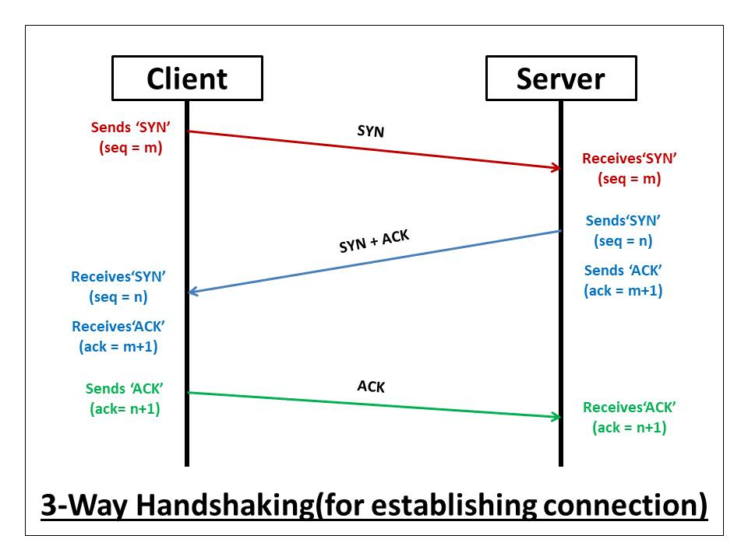

1. Initially when the client wants to establish communication with the server, It will send SYN (Synchronize Sequence Number).
2. When server receives SYN, The server understands that the client is ready for data transfer.
3. If the server is also ready for data transfer, it will send +ve ACK. If the server is not ready for data transfer, it will send -ve ACK.
4. When client receives a +ve ACK, it understands that the server is ready for data transfer, then client will give one more ACK. It indicates that the client is ready with the data and it will transfer the data.
5. Client after sending the ACK only, It will transfer the actual information.

IP version 4 – 32 bit addressing

IP version 6 –128 bit addressing

IP v4 : - 32 bits are divided into 4 Octets known as Dotted Binary Notation. Octets are separated with .

IP v6 :- Divided along 16 bit boundaries. Each 16 bit block is converted into a 4 digit hexadecimal number. Separated by colons (Colon Hex Notation).

Total IP address range:

0.0.0.0 – 255.255.255.255

IP addressing schemes – 5 classes:-

1. Class A
2. Class B
3. Class C
4. Class D
5. Class E

Class A Priority – 0

Class B Priority - 10

Class C Priority - 110

Class D Priority - 1110

Class E Priority – 1111

Class A range:-

* + 1. to 127.255.255.255

Class B range:-

128.0.0.0 to 191.255.255.255

Class C range:-

192.0.0.0 to 223.255.255.255

Class D range:-

224.0.0.0 to 239.255.255.255

Class E range:-

240.0.0.0 to 255.255.255.255

Octet Format:

Class A – N.H.H.H

Class B – N.N.H.H

Class C – N.N.N.H

Class A -

|  |  |
| --- | --- |
| Class A Networks | 126 |

|  |  |
| --- | --- |
| Hosts per Network | 16,777,214 |

Class B – 16384 Networks and 65534 Hosts

Class 2 – 2097152 Networks and 254 Hosts

Blocking and Caching are associated with IOCS and Disk Scheduling.

Memory:

Code segment: .exe file of the program

Data segment: Global var and static variables

Stack segment: local variables, functions

Heap segment: Dynamic variables

Void abc(){

int a=0;

static int s;

printf(“%d,%d\n”,++a,++s);

}

Void main(){

abc() //1,1

abc() //1,2

abc() //1,3

}

Segmentation and Paging:

1. Paging:- If the memory is divided into fixed size blocks, then it is called Paging.
2. Segmentation:- If the memory is divided into variable sized blocks, then it is called Segmentation.

In both segmentation and paging, Physical memory will be divided into equal parts.

Differences between Paging and Segmentation:-

|  |  |  |
| --- | --- | --- |
| Feature | Paging | Segmentation |
| Division Unit | Fixed Size | Variable Size |
| Managed by | Operating System | Compiler |
| Unit size determined by | Hardware | User / Programmer |
| Address Structure | Page number + Page Offset | Segment number + Segment Offset |
| Data Structure used | Page Table | Segment Table |
| Fragmentation Type | Internal Fragmentation | External Fragmentation |
|  |  |  |

Pool based allocation of memory achieves better usage. Memory can be preempted from inactive programs and used to accommodate active programs. It is called Swapping.